**Project proposal: Effect of Clothing Display on Consumer Online Shopping Behavior**

Team 10: Ling Hong , Erezi Ogbo , Oluwatobi Oladiran , Xinlu Yao, Mingjia Yuan

### **1. Introduction**

A good display makes people walk into the store and also helps in making them feel like taking a look around (Jamnani & Daddikar, 2015). However, the shopping industry has been revolutionized by the success of online shopping. According to the Fortune magazine, shoppers are buying more things online than in stores and in 2016, shoppers completed more than half of their shopping online for the first time. Reports show that in 2017, the shopping giant, Amazon, was responsible for 4% of all retail sales in the US. As Amazon launches Prime Wardrobe, a feature that allows consumers to buy clothes and try at home, online shopping of clothing items is expected to increase significantly. As customers seek to purchase more clothing items online, shops are employing various ways to display these items to increase customer engagement and ultimately drive sales.

This project seeks to understand to what extent clothing merchandise display influence consumer buying behavior from an online retailer such as Amazon.

#### **Research question**

How does the use of a mannequin or model to display a clothing item in an online marketplace affect consumer purchase?

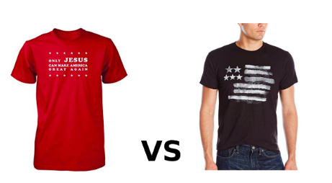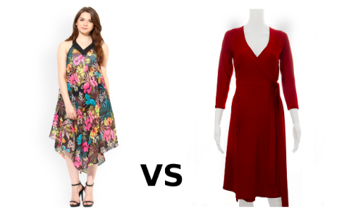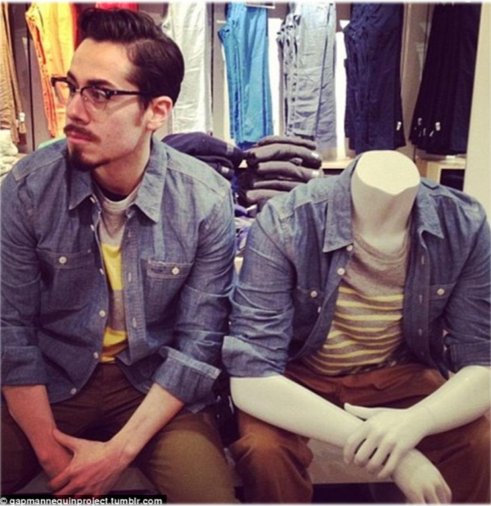

#### **Benefits of the project**

The findings from this project can be used by online retailers to guide the display of clothing items, thereby influencing the buying behavior of potential consumers and increasing sales.

### **2. Experiment design**

1. **Dependent variable Y:** whether the customer clicks to buy or not.
2. **Treatments X:**

there will be two treatments - 1) use people to display clothing 2) use mannequin to display clothing. The control group will only see the clothes displaying without a model.

1. **Variables to control ɛ:**

demographic variables (age, gender, race, education, income, nationality), shopping frequency, price, clothing style.

1. **Ways to control:**

Randomized control trial: randomly assign individuals to treatment.

Keep the price and clothes style be the same in two versions.

1. **Models and statistical techniques involved:** the statistic model we are going to use is Regression. We will also include interactions between the treatment and some of the control variables; we are going to use the Chi-squared test to ensure that selection is avoided. Below is the workflow for our project.

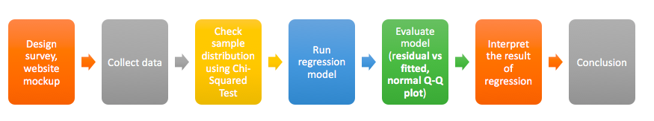

Workflow

### **3. Survey Design**

We simulate the shopping scenario by distributing online surveys randomly. The platform we use to design and distribute the survey is Qualtrics.

The survey can be accessed through this link: <https://cmu.ca1.qualtrics.com/jfe/form/SV_3pVSoYZwq9iB19H>

1. **Introduction**

In the introduction of the survey, we eliminate potential bias caused by gender and size.

*In this section, imagine you are shopping online for clothes for yourself.*

*You can also shop for a family member or friend of either gender.*

*Assume that the clothes shown are in the desired sizes.*

1. **The choice of clothing items**

We include different types of clothing items e.g. tops, pants, jackets … to meet the need of as many participants as possible. In consideration of gender, we have 5 items for female and 5 items for male equally.

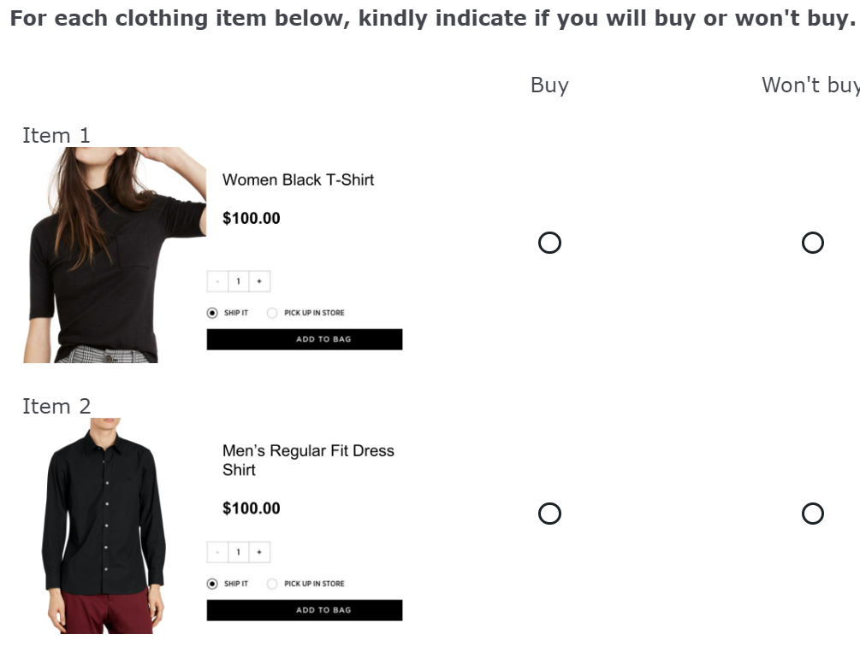 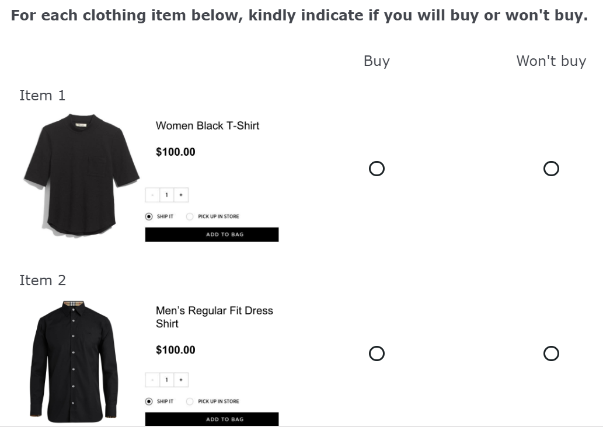

1. **Attention check question**

We design an attention check question to ensure the quality of the response. For item 7, all participants should click “buy”.

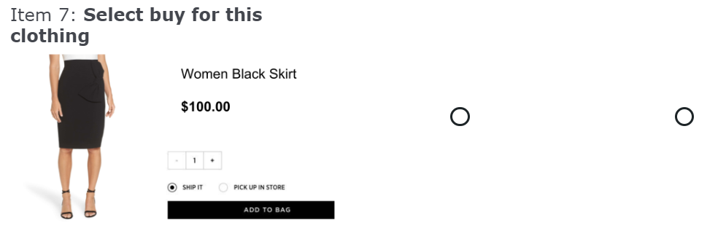

### **References**

* *Chi-Square Goodness of Fit Test.* (2018). *Stattrek.com*. Retrieved 3 November 2018, from <https://stattrek.com/chi-square-test/goodness-of-fit.aspx>
* *6 A/B testing ideas for your Product Pages*. (2017). *Mockingfish.com*. Retrieved 4 November 2018, from <https://www.mockingfish.com/blog/6-ab-testing-ideas-for-your-product-pages/>
* Jamnani, M. A., & Daddikar, M. P. (2015). Influence of visual merchandising on customer buying decision- a study of Inmark retail store. Retrieved 4 November 2018, from *Asia Pacific Journal of Research Vol: I.* Issue XXX

#### *Fortune.com*. (2018). *Fortune*. Retrieved 4 November 2018, from <http://fortune.com/2016/06/08/online-shopping-increases/>